Practical No: 10

**Aim:** Interfacing Raspberry pi with RFID.

**Hardware Required:**

1. Raspberry Pi 3B+
2. 2.Ethernet Cable
3. Monitor
4. HDMI to VGA convertor
5. Micro SD card (any class best is class 10)
6. Adaptor with 5v 2A
7. USB mouse
8. USB keyboard
9. Relay board
10. Female – Female jumper wires. (7 numbers)
11. Female – Male jumper wires(3 numbers)
12. RFID-RC522
13. Buzzer
14. LED (red and green)
15. Bread board

**Software Required:**

1. Raspbian OS
2. Thonny Python IDE

**Procedure:**

1. **Hardware Setup:**

* Connect as given below…
* **SDA** connects to Pin **24**.
* **SCK** connects to Pin **23**.
* **MOSI** connects to Pin **19.**
* **MISO** connects to Pin **21**.
* **GND** connects to Pin **6**.
* **RST** connects to Pin **22**.
* **3.3v** connects to Pin **1**.
* **GPIO20** connects to anode **LED red**
* **GPIO21** connects to anode **LED green**
* **GPIO16** connects to anode **Buzzer**

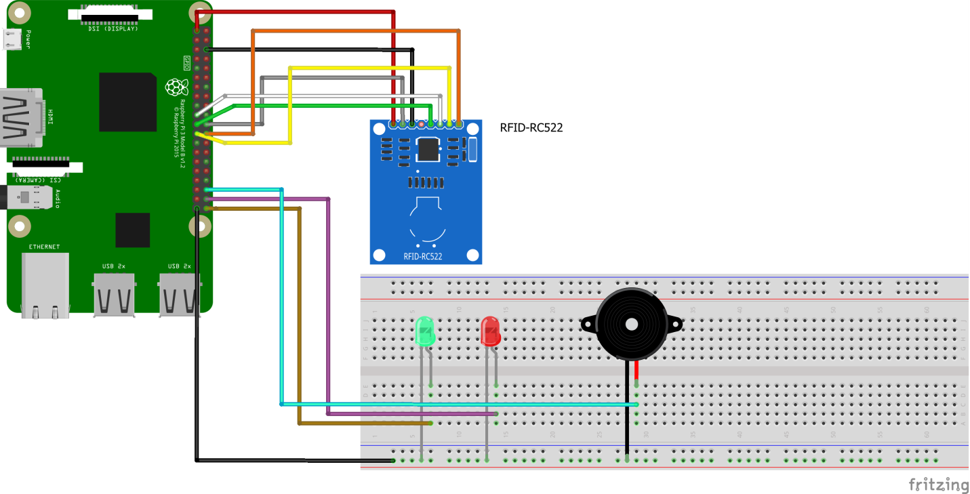

1. **Software Setup:**

* Navigate to Start 🡺 Preferences 🡺 Raspberry Pi Configuration 🡺 Interfaces

Enable SPI and click on OK

* Reboot
* Open Terminal and type the following commands …
* sudo apt update
* sudo apt upgrade
* sudo pip3 install mfrc522
* open Programming🡺 Thonny Python IDE 🡺 New
* Type the following code in a new file to get the ID of the tag…

*import RPi.GPIO as GPIO*

*from mfrc522 import SimpleMFRC522*

*reader = SimpleMFRC522()*

*try:*

*id, text = reader.read()*

*print(id)*

*print(text)*

*finally:*

*GPIO.cleanup()*

* Run the file by pressing play button in the top
* Place the tag near the RFID.
* Jot down the ID from the terminal
* Type the following code in a new file to write to tag…

*from mfrc522 import SimpleMFRC522*

*import RPi.GPIO as GPIO*

*reader = SimpleMFRC522()*

*try:*

*text = input('New data:')*

*print("Now place your tag to write")*

*reader.write(text)*

*print("Written")*

*finally:*

*GPIO.cleanup()*

* Run file by pressing the run button on the top
* Enter a name for your tag press enter (jot down what you have written)
* Place the tag near the RFID reader wait for message written
* Create a new python file and type the following code…

*import sys*

*from mfrc522 import SimpleMFRC522*

*from time import sleep*

*from gpiozero import Buzzer*

*import RPi.GPIO as GPIO*

*reader = SimpleMFRC522()*

*autorizedGreenLed=Buzzer(21)*

*unautorizedRedLed=Buzzer(20)*

*buzzer=Buzzer(16)*

*def authenticationCheck(id,person):*

*if (id ==****joted ID*** *and person==****'joted Name'****):*

*print("Wellcome",person)*

*buzzer.beep(0.1,0.1,4)*

*autorizedGreenLed.beep(0.5,0.5,10)*

*else:*

*print("Un-Authoried personal")*

*buzzer.beep(0.5,0.5,4)*

*unautorizedRedLed.beep(0.3,0.3,10)*

*try:*

*while True:*

*print("Hold your tag near the reader")*

*id, person = reader.read()*

*authenticationCheck(id,person.strip())*

*sleep(5)*

*except KeyboardInterrupt:*

*autorizedGreenLed.off()*

*buzzer.off()*

*unautorizedRedLed.off()*

*GPIO.cleanup()*

*Raise*

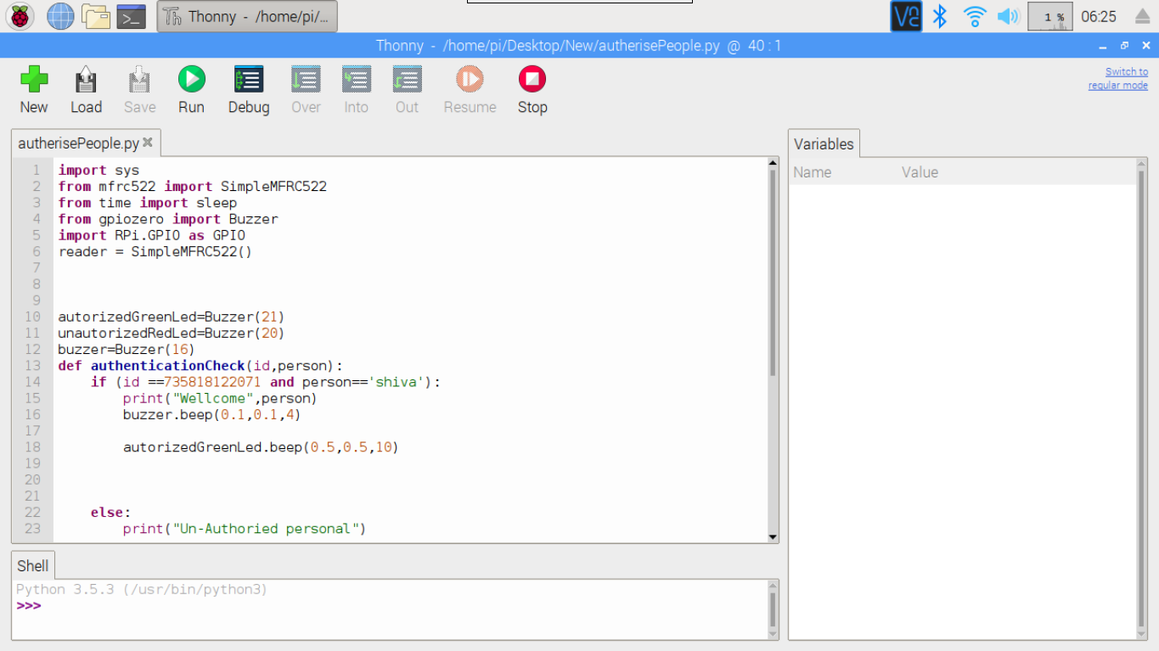

**Precautions:**

* If it is a fresh flash of Raspbian OS “*sudo apt update”* and “*sudo apt upgrade”* is a must thing.
* Connect the components before powering on the device and double check your connections.
* When you are reading and writing to tag make sure you are in close proximity with the RFID.

**Conclusion:**

* We are able to authenticate a person on the basis of the physical tag a person is carrying.

